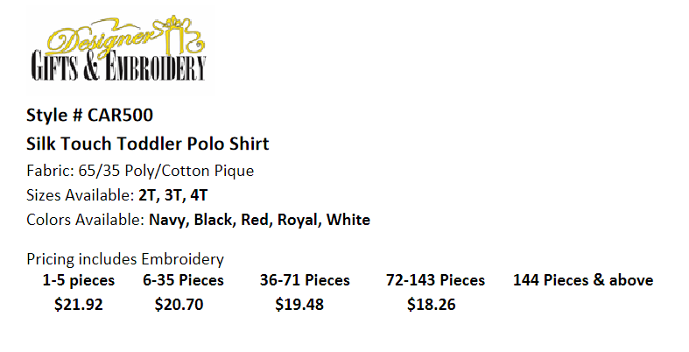

Logo

Style #
Name of Item
Fabric Content:
Sizes Available:
Colors Available:
Pricing Includes Embroidery
1-5 Pieces 6-35 Pieces 36 -71 Pieces 72-143 Pieces 144 Pieces & Above

